**Exercise 4**: Arrange-Act-Assert **(AAA) Pattern**, **Test Fixtures**, **Setup** and **Teardown Methods** in **Junit**

- The **Arrange-Act-Assert (AAA) pattern** is a simple, structured way to write **readable, maintainable unit tests**.  
 It divides your test into **three clear sections**, each with a specific role:

1. **Arrange**: Set-up everything needed for test

2.**Act**: Execute the functionality you want to test (the method under test)

3.**Assert**: Check that the outcome is what you expected

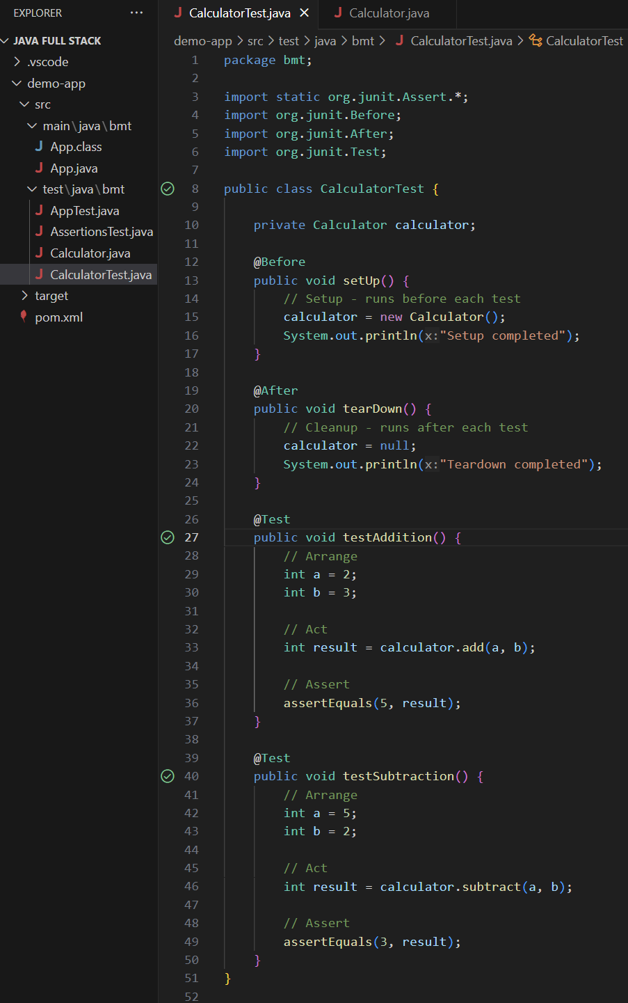**(Solution)**: Let’s test the AAA pattern by making a test-class named **CalculatorTest.java**

**▪** The test class **CalculatorTest** is not part of our application’s core logic, **It’s purely for testing**.

**▪** The supporting **class Calculator** is what we are *actually testing*.

**-** Therefore, make a supporter class for the above test-classnamely **Calculator.java:**

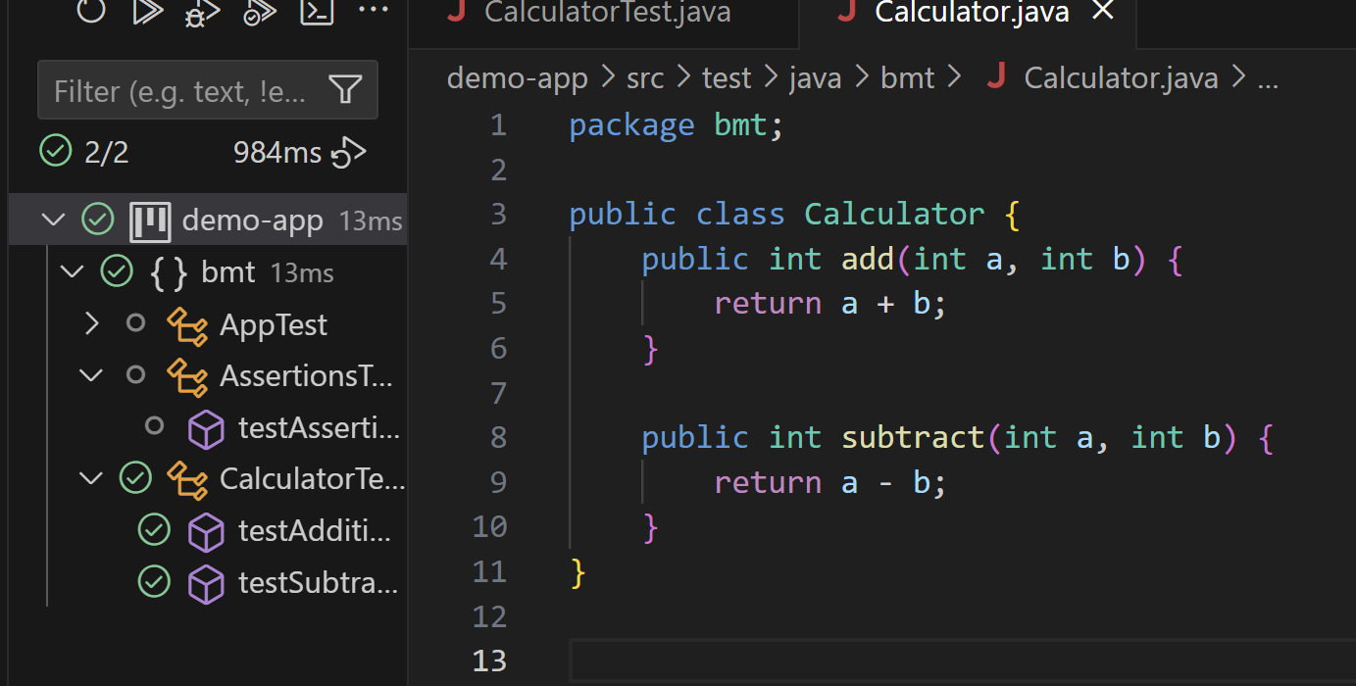

The **@After** and **@Before** have been used in the **CalculatorTest** class.

Note: The ***Green-tick*** in the above file indicates the ***successful run of test-cases***.

**\*\*\*\*\*\*\*\*\*\*\*\*\*\*\*\*\*\*\*\*\*\*\*\*\*\*\*\*\*\*\*\*\*\*\*\*\*\*\*\*\*\*\*\*\*\*\*\*\*\*\*\*\*\*\*\*\*\*\*\*\*\*\*\*\*\*\*\*\*\*\*\*\*\*\*\*\*\*\*\*\*\*\*\*\*\*\*\*\*\*\*\*\*\*\*\*\*\*\*\*\*\*\*\*\*\*\*\*\*\*\*\*\*\*\*\*\*\*\*\*\*\*\*\*\*\*\*\*\*\*\*\*\*\*\*\*\*\*\*\*\*\*\*\*\*\*\*\*\***